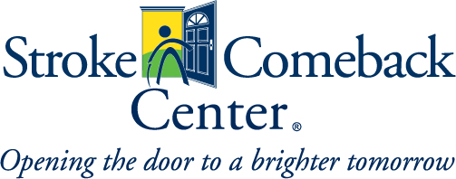 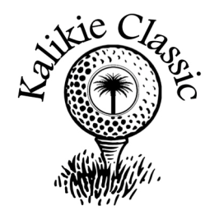

**Event Overview**

**Name of Event:** 15th Annual Kalikie Classic

**Date:** Wednesday, September 20, 2023, 9:00 am

**Place:** Raspberry Falls Golf and Hunt Club, Leesburg, VA

**Event Chair:** Christie Arnold

**Event Summary:** The Stroke Comeback Center is hosting the 15th Annual Kalikie Classic Golf Tournament. This will be a fun day of golf with a special luncheon honoring stroke survivor, Christie Arnold and the Founding Fathers who started this effort 16 years ago.

**About Stroke Comeback Center**

The Stroke Comeback Center is a community-based nonprofit organization located in Vienna, Virginia. The Center is the only nonprofit in the area that provides programs for stroke and brain trauma survivors on a long-term basis. We provide a place of hope for all those who no longer have insurance to cover therapy costs. Through private donations and special fundraising events, the Stroke Comeback Center can continue to provide programs and support for persons from all income levels regardless of ability to pay. With your support, our survivors will always have a wonderful place to grow, rebuild skills and reclaim their lives.

**Sponsorships and Registration**

Please review the attached sponsorship opportunities.

If you would prefer to pay by check, please complete the attached sponsorship form.

________________________________________________________________________________________________________

Stroke Comeback Center 145 Park Street S.E, Vienna, VA 22180

**www.strokecomeback****center.org**

703-255-5221

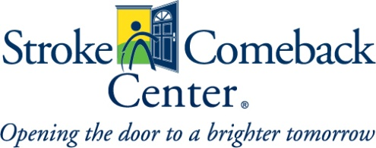 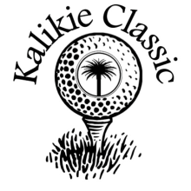

**Sponsorship Registration Form, if paying by check**

I/We support the Stroke Comeback Center’s 15th Annual Kalikie Classic

15th Anniversary Presenting $15,000

Kalikie Partner $10,000

Golf Carts Sponsor $5,000

Beverage Cart Sponsor $3,000

Luncheon Sponsor $3,000

Closest to the Pin $1,500

Closest to the Line $1,500

Grab-and-Go Breakfast $1,500

Mahalo Sponsor $1,000

Goodie Bag Sponsor $750

Aloha Sponsor $250

Kalikie Friend $150

|  |  |
| --- | --- |
| Sponsor Name: |  |

Please print name exactly as you wish to be acknowledged

|  |  |  |  |  |  |
| --- | --- | --- | --- | --- | --- |
| Contact Name: |  | | | | |
| Title: |  | | | | |
| Street Address: |  | | | | |
| City: |  | State: |  | Zip Code: |  |
| Phone: |  | | | | |
| Email: |  | | | | |

**Please make check payable to**: Stroke Comeback Center

If a foursome is included in your sponsorship package, we will contact you regarding the names of your golfers closer to the tourney.

**Please mail completed form to:**

Stroke Comeback Center

145 Park Street, SE

Vienna, VA 22180

Attn: Kalikie Classic