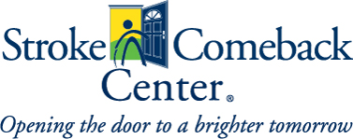
Vienna location: 145 Park Street, SE
Vienna, Virginia 22180
703-255-5221
Rockville location: 50 W Edmonston Drive Suite 301
Rockville, MD 20852
301-605-7620
Loudoun Location: 224-D Cornwall St. NW Suite 305
Leesburg, VA 20176
571-919-6090
www.strokecomebackcenter.org
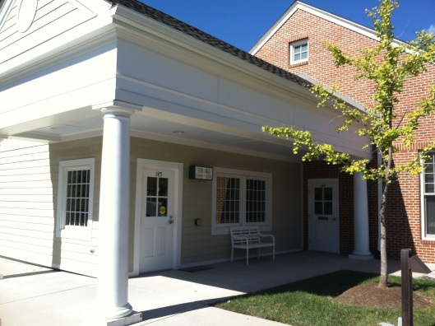
WHO We are a non-profit community-based organization located in Vienna, Virginia. Rockville, MD and Leesburg, VA. Our members are made up of a diverse group of stroke and brain trauma survivors of all ages – 25 to 85 years old!

WHAT We provide affordable long-term communication and exercise classes for stroke and brain trauma survivors. We offer a wide variety of classes to meet the individual needs of our members, along with social programs and caregiver support. Our fees are affordable, and we have a sliding scale based on family income. No one is ever turned away for inability to pay.

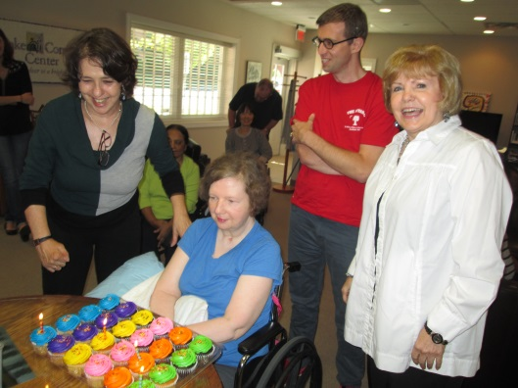
WHEN Classes are offered throughout the week, Monday through Friday. Our programs run in 9-week sessions, allowing us to modify our schedule to meet the changing needs of members.

WHERE We now have three brick and mortar locations. We are in the heart of Vienna, near the intersection of Route 123 and Park Street. Our Rockville location is near the intersection of W Edmonston Drive and Rockville Pike. Our Leesburg location is in the heart of Leesburg near Cornwall St. and Market St. W.

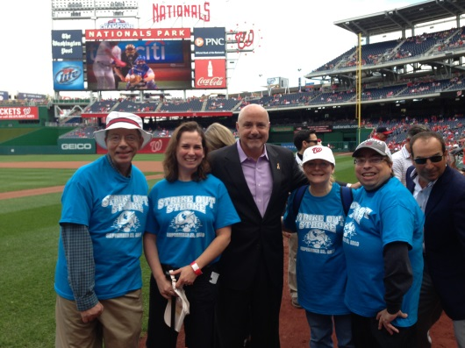
WHY Research indicates that stroke and brain trauma survivors can continue to improve over many years. We believe that these individuals deserve the right to express themselves and to become reinvested in life.

HOW Please visit our website for more information. An initial meeting with one of our professionals introduces our community and offers recommendations to meet the individual needs of new members.

