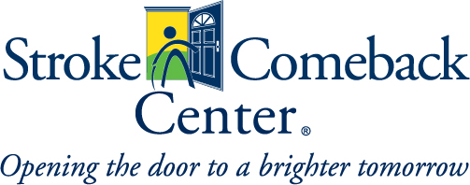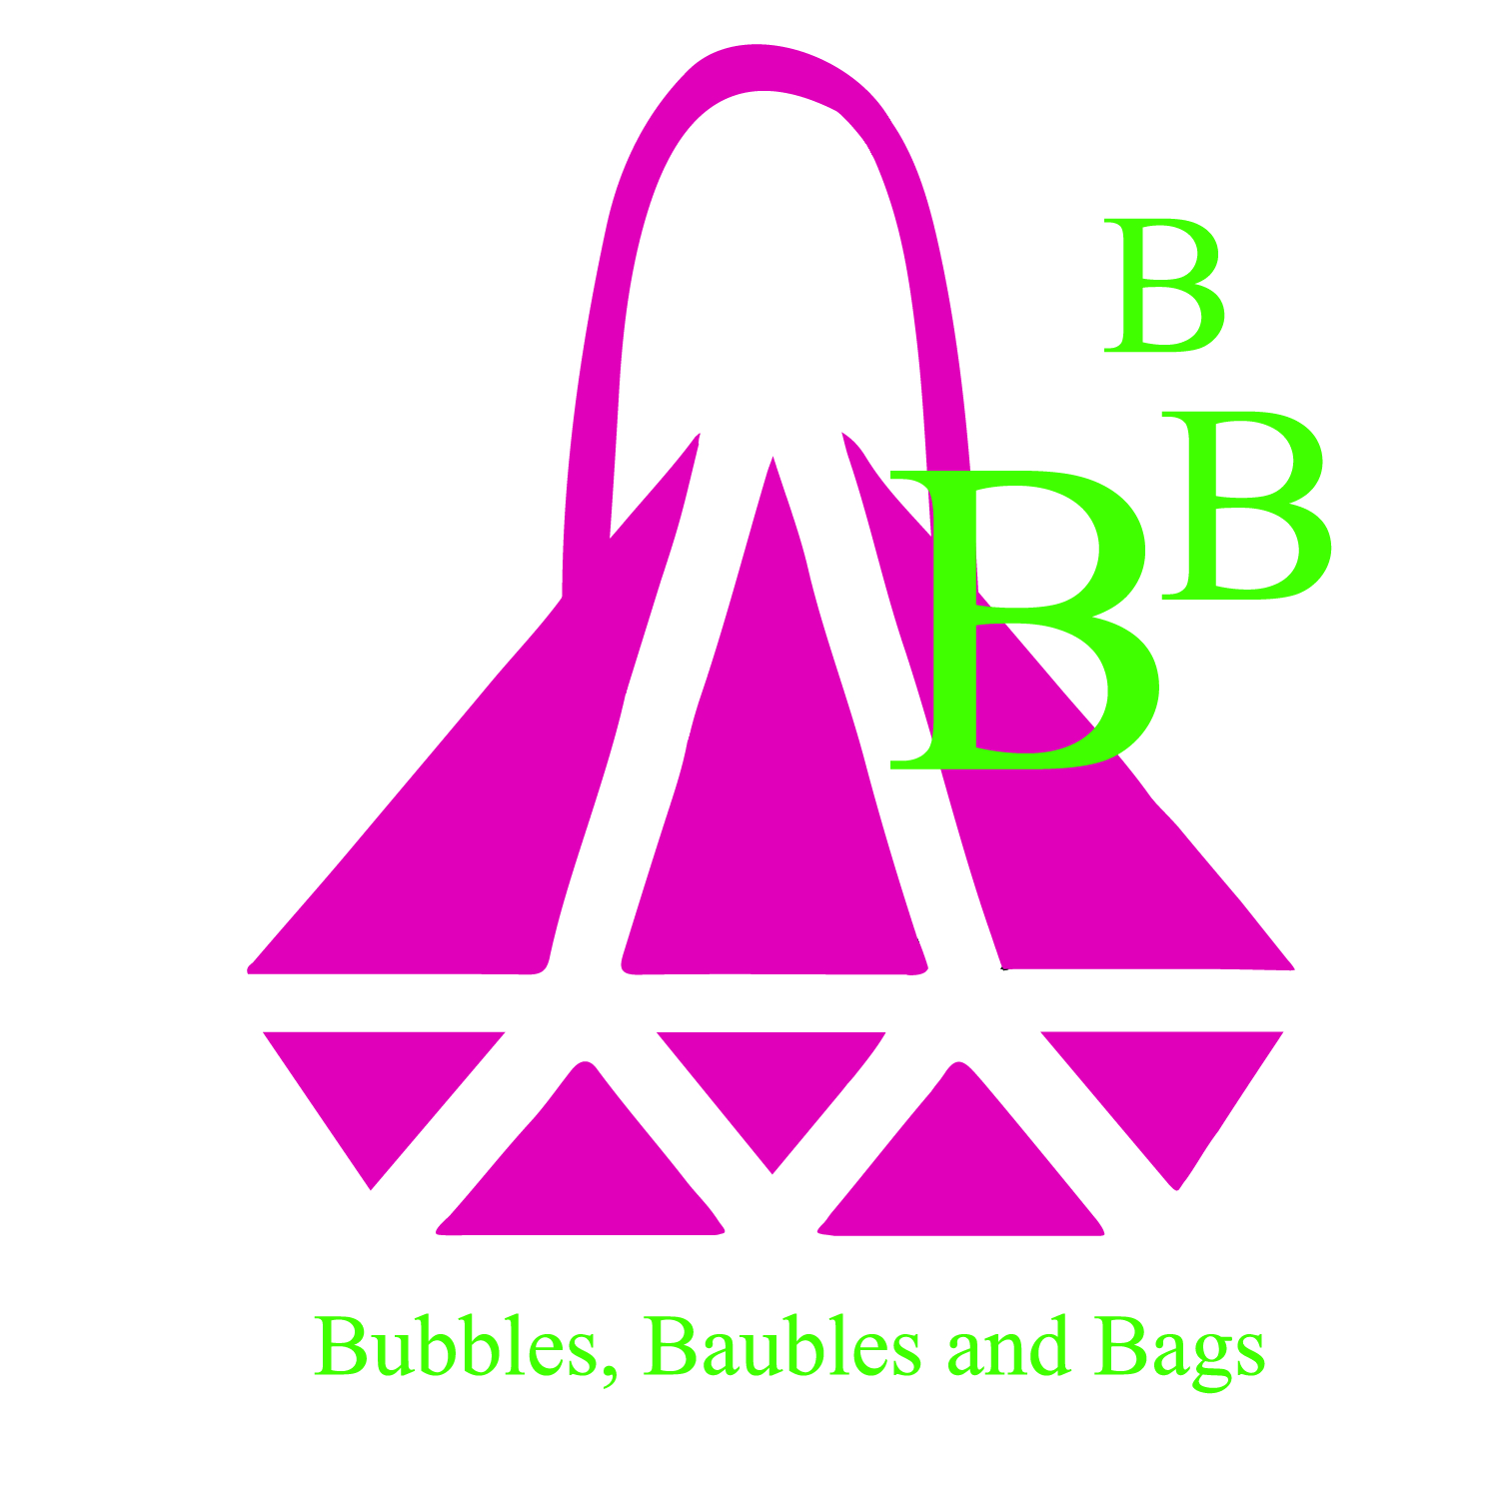

Event Overview

Name of Event: Bubbles, Baubles and Bags

Date: Saturday, April 29, 2017; 11:00 am

Place: Westwood Country Club, 800 Maple Avenue, Vienna, Virginia 22180

Event Chair: Jeannemarie Davis

Expected Audience: 200 community leaders, philanthropists, friends of the Stroke Comeback Center

Event Summary: The Stroke Comeback Center is hosting the Bubbles, Baubles and Bags luncheon to support its programs for survivors of stroke and brain trauma. This event will be a wonderful afternoon sipping champagne, with an elegant lunch and a chance to bid on designer and celebrity handbags, tempting baubles and other items in both our live and silent auctions. A fashion show by Bloomingdale’s will showcase the latest spring fashions for 2017.

About Stroke Comeback Center
The Stroke Comeback Center is a community-based nonprofit organization located in Vienna, Virginia. The Center is the only nonprofit in the area that provides programs for stroke and brain trauma survivors on a long-term basis. We provide a place of hope for all those who no longer have insurance to cover therapy costs. Through private donations and special fundraising events, the Stroke Comeback Center can continue to provide programs and support for persons from all income levels regardless of ability to pay. With your support, our survivors will always have a wonderful place to grow, rebuild skills and reclaim their lives.

Sponsorships and Tickets
Sponsorships are available. Please review the sponsorship opportunities.

Tickets are $125* per person and may be purchased online at www.strokecomebackcenter.org or by contacting the Development Office at events@strokecomebackcenter.org.

Sponsorship Levels
Presenting Sponsor: $5,000.00
- Recognized from podium during luncheon
- Company logo in program and promotional materials
- Prominent recognition in printed and electronic correspondence
- Acknowledgement through our social media outlets
- Opportunity to place marketing items in gift bags
- Table for ten guests at luncheon
Diamond Sponsor: $2,500.00
- Recognized from podium during luncheon
- Prominent recognition in printed and electronic correspondence
- Acknowledgement through our social media outlets
- Five guests at luncheon
Platinum Sponsor: $1,000.00
- Prominent recognition in printed and electronic correspondence
- Acknowledgement through our social media outlets
- Three guests at luncheon
Silver Sponsor: $500.00
- Prominent recognition in printed and electronic correspondence
- Acknowledgement through our social media outlets
- One guest at luncheon
If you have any questions about the Bubbles, Baubles and Bags sponsorships, please contact us at events@strokecomebackcenter.org

Stroke Comeback Center 145 Park Street S.E, Vienna, VA 22180
www.strokecomebackcenter.org
703-255-5221

Sponsorship Registration Form, if paying by check

I/we support the Stroke Comeback Center’s Bubbles, Baubles and Bags Luncheon

_____Presenting Sponsor $5,000
_____Diamond Sponsor $2,500
_____Platinum Sponsor $1,000
_____Silver Sponsor $ 500
Sponsor Name
Please print name exactly as you wish to be acknowledged

Contact Name Title
Address

City State Zip Code

Phone___ Email

Please make check payable to Stroke Comeback Center.

Individual ticket purchase and sponsor payment can also be made online at: http://SCCenter.eventbee.com/event?eid=191855022

Please send completed form to: Development Office, Stroke Comeback Center, 145 Park St SE, Vienna, VA 22180

